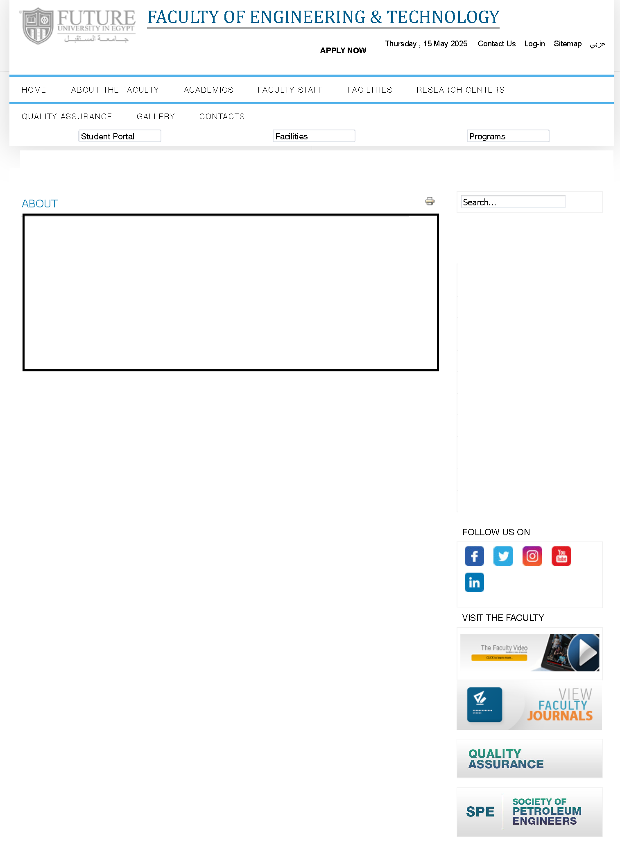

**Architectural Engineering Program**

**Architectural Engineering Program**

Program coordinator welcome message

Program tree

Courses description

Resources and laboratories

Students' projects & activities

Industrial Advisory Board

Back to All Programs

**Image**

* **Overview of the Program**

The Department of Architectural Engineering offers a Bachelor of Science (BSc.) program in Architectural Engineering that is based on a five-year (ten-semester) credit hour system. The program starts with a year of general introduction of studying basic sciences in engineering, followed by four specialized years of studying architecture.

The program aims to develop a creative, diverse, and rigorous approach to design from the outset. Most of the design teaching relies on a one-to-one tutorial basis with frequent review sessions. Nearly all design instructors and tutors are practicing architects or are design specialists who bring innovative design ideas to the faculty. History and theory, technology, human studies, and professional studies courses support the design work in each year and are assessed through a combination of coursework, essays, and examinations. To complete the BSc in Architectural Engineering, a student has to complete 164 credit hours during his/her study successfully.

* **Program Mission**

The Architectural Engineering Program provides a promising academic environment that enables qualifying distinguished architectural engineers who can compete nationally and regionally and comply with the requirements of the job market professionally and ethically. It also motivates conducting scientific research and contributes to the community service and environment development.

The Architectural Engineering program provides a promising academic environment that enables qualifying distinguished architectural engineers who can compete nationally and regionally, complies with the requirements of job market professionally and ethically, motivates conducting scientific research, contributes to community service and environment development.

* **Program Aims**

PA1. Identify, formulate, and solve complex architectural engineering problems by applying principles of engineering, science, and mathematics.

PA2. Apply architectural engineering design to produce solutions that meet specified needs with consideration of public health, safety, and welfare, as well as global, cultural, social, environmental, and economic factors.

PA3. Communicate effectively with a range of audiences.

PA4. Recognize ethical and professional responsibilities in engineering situations and make informed judgments, which must consider the impact of architectural engineering solutions in global, economic, environmental, and societal contexts.

PA5. Function effectively on a team whose members together provide leadership, create a collaborative and inclusive environment, establish goals, plan tasks, and meet objectives.

PA6. Develop and conduct appropriate experimentation, analyze and interpret data, and use engineering judgment to draw conclusions.

PA7. Acquire and apply new knowledge as needed, using appropriate learning strategies.

PA8. Use techniques, skills and modern engineering tools necessary for architectural engineering practice.

PA9. Demonstrate leadership qualities, business administration and entrepreneurial skills.

PA10. Recognize his/her role in promoting the engineering field and contribute in the development of the profession and the community.

* **Graduate’ Attributes**

The graduate of the architectural engineering program must:

* GA1. Identify, formulate, and solve complex architectural engineering problems by applying principles of engineering, science, and mathematics.
* GA2. Apply architectural engineering design to produce solutions that meet specified needs with consideration of public health, safety, and welfare, as well as global, cultural, social, environmental, and economic factors.
* GA3. Communicate effectively with a range of audiences.
* GA4. Recognize ethical and professional responsibilities in engineering situations and make informed judgments, which must consider the impact of architectural engineering solutions in global, economic, environmental, and societal contexts.
* GA5. Function effectively on a team whose members together provide leadership, create a collaborative and inclusive environment, establish goals, plan tasks, and meet objectives.
* GA6. Develop and conduct appropriate experimentation, analyze and interpret data, and use engineering judgment to draw conclusions.
* GA7. Acquire and apply new knowledge as needed, using appropriate learning strategies.
* GA8. Use techniques, skills and modern engineering tools necessary for architectural engineering practice.
* GA9. Demonstrate leadership qualities, business administration and entrepreneurial skills.
* GA10. Recognize his/her role in promoting the engineering field and contribute in the development of the profession and the community.
* **Career opportunities**

All students of architecture from Future University find suitable professional job offers when they graduate; either locally or internationally, as the program is designed to prepare graduates to become professionals who will contribute to the socio-economic and cultural development of Egypt and the broader global community through responsible participation in the process of design, construction, and interpretation of the built environment.

* **Students' training and research**

In order to be able to graduate, each student has to have had at least three months of training during the summer. If a student cannot get himself/herself a summer training opportunity, then the University will offer him/her one. These may cover the wide spectrum of designing in an architectural firm or a consultant's office, or supervising work on a construction site. This training actually raises the students' awareness, understanding, and comprehension of what is going on in the real professional life, whether in the field, or in a consultant's office.

During their study, students of architecture are always required to research different building types that are relevant to their design projects. They are also required to submit research in different courses, related to the topics they study.

* **Under approval new bylaw (144 CH’s)**

The Under-approval new bylaw of The Architectural Engineering Program is a four-year, 144 Credit Hours (CH) program consisting of eight semesters. The curriculum includes both compulsory and elective courses, allowing students to tailor their education to their interests. The program incorporates five educational modules:

* University requirements module of 12 CH, including 6 CH Compulsory course (3 courses) and 6 CH elective course (3 courses)
* Faculty requirements module of 30 CH, including 28 CH Compulsory course (12 courses) and 2 CH elective course (1 course).
* Specialty requirements module of 55 CH
* Sub-specialty requirements module of 47 CH, including 27 CH Compulsory courses (8 courses) and 20 CH elective courses.
* The practical training of 150 training hours divided into 2 training modules each 75 hours without credit hours.

It is expected to be enrolled starting from fall 2025.