**Program coordinator welcome message**

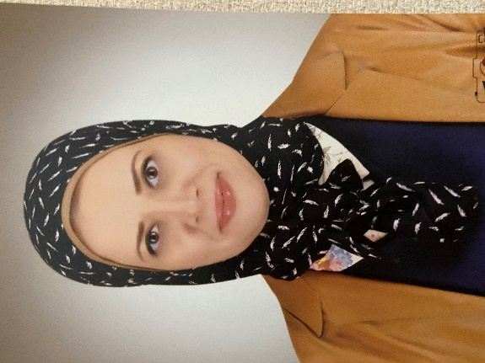

Welcome to Biomedical Engineering Program at FUE. We are excited to have you join our vibrant community, where you’ll gain the knowledge and skills to make a real impact in the healthcare industry locally and globally. Our dedicated faculty members strive to equip you with both scientific knowledge and practical experience in biomedical engineering. Through hands-on training in leading hospitals and medical device companies, you will gain valuable skills to work with cutting-edge technologies in the field. We are excited to support you on this journey and wish you success in your studies and future careers. Welcome to our BME family!

**Assoc. Prof. Dr. Neven Saleh**