The electrical engineering department is equipped with 5 Laboratories that serve the specialized courses of the Computer and Intelligent Systems Engineering program, as indicated below.

**Basic Electrical Engineering Lab.**

* Location: Room A2.6
* Capacity: 24 Students

Main Equipment / Apparatus

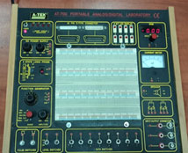

Basic electronic boards, Assembly boards, Basic logic gates, Combinational circuits, Sequence circuits, Memory circuits, Converter circuits, Diode clipper and clamper, Rectifier, Differential and integral circuits module, Transistor amplifiers circuit, engineering circuit, Multistage amplifiers circuit, Oscillator circuit, Voltage regulator circuit, Modulation circuit, Electronic Circuit Fundamentals, Op-AMP circu.it modules, Basic electronics experiment module, Magnetism element, Oscillator Experiment, Analog-Digital Lab, Digital Oscilloscopes. Digital Multimeters, RLC meter, Function Generators, Power Supplies Analog Oscilloscopes, Frequency-meter/ Counter

**Advanced Electronics and Communication Lab.**

* Location: Room B3.3
* Capacity: 16 Students

Main Equipment / Apparatus

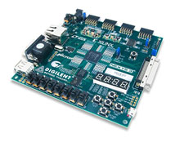

**Communication Lab.:** Modulation & Coding (Interactive Computer trainer), FM Radio System (Transmitter & Receiver), AM Radio System (Transmitter & Receiver), WIMAX Trainer, IPTV Trainer, CDMA Trainer, Network Switch & Router.  
  
**Microprocessors Lab.:** 8086 microprocessor trainer kits, Arduino Mega 2560 Development Board, 8051 Microcontroller Development Board, PIC Microcontroller Development Board.  
  
**FPGA Lab.:**Nexys 3 Spartan-6 FPGA Trainer Board 410-182, ZedBoard Zynq-7000 ARM/FPGA SoC Dev 410-248, Genesys 2 Kintex-7 FPGA Development Board 410-300, CoolRunner-II CPLD Starter Board 410-146, Nexys 4 DDR Artix-7 FPGA, Trainer Board 410-292  
  
**Measuring Instruments:**Analog Oscilloscope 100 MHz, Digital Oscilloscope 500 MHz, Mixed-Domain Oscilloscope 500 MHz, Spectrum Analyzer 3 GHz, RF Synthesizer 1.2 GHz, Function Generator 12.5 MHz, Digital Multi Meter

**Graduation Projects Lab.**

* Location: Room B4.5
* Capacity: 16 Students

Main Equipment / Apparatus

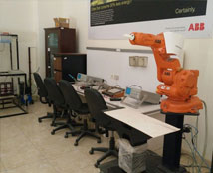

Analog Oscilloscopes, Function Generators, Digital Multi Meters, Digital logic lab., Hot air Soldering Kits, Cutting Pliers, soldering iron with stand, Electronics pliers, Solder Sucker, small size cutting saw for PCB, Etching Tank ET-20 for PCB, Drill, Pocket Pack Screwdriver Set, Caustic welding, Electric blower, PCB Manufacturing:: Raw boards, Acid