The electrical engineering department is equipped with 4 Laboratories that serves the specialized courses of the Electrical Power Engineering program, as indicated below.

**Basic Electrical Engineering Lab.**

* Location: Room A2.6
* Capacity: 24 Students

Main Equipment / Apparatus

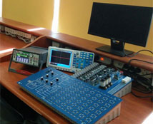

Basic electronic boards, Assembly boards, Basic logic gates, Combinational circuits, Sequence circuits, Memory circuits, Converter circuits, Diode clipper and clamper, Rectifier, Differential and integral circuits module, Transistor amplifiers circuit, engineering circuit, Multistage amplifiers circuit, Oscillator circuit, Voltage regulator circuit, Modulation circuit, Electronic Circuit Fundamentals, Op-AMP circu.it modules, Basic electronics experiment module, Magnetism element, Oscillator Experiment, Analog-Digital Lab, Digital Oscilloscopes. Digital Multimeters, RLC meter, Function Generators, Power Supplies Analog Oscilloscopes, Frequency-meter/ Counter

**Electrical Machines Lab.**

* Location: Room B3.1
* Capacity: 16 Students

Main Equipment / Apparatus

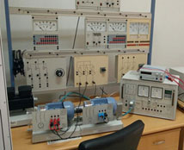

Torque and Speed Control, DC Dynamometer Machines, DC Compound Machines, Variable Frequency Drives, DC motor Speed Control, 3-phase Squirrel-Cage Induction Motors, 3-phase Synchronous Machines, Synchronizing Board, 3-phase Resistive Loads, DC Voltmeters & Ammeters, 1-ph & 3-ph Measurement Units, 1-phase Capacitor Start Induction Motors, Control Unit, Pendulum Machine, Power Supplies, Field Rheostats, Motor Starters, 3-phase Slip-ring Induction Motor, Tacho-Generator, 1-phase Universal Motor, 1-phase Transformer, 3-phase Transformer, 3-phase Resistive Loads, 3-phase Inductive Loads, 3-phase Capacitive Loads, Double Voltmeter, Double Frequency meter, P.F. Meter, Multi-meters, Wattmeters.

**Power Electonics Lab.**

* Location: Room B5.5a
* Capacity: 16 Students

Main Equipment / Apparatus

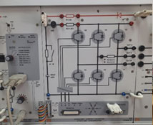

Digital universal control unit (microcontroller), RLC load with temperature line and 3 indicating lamps, Three-phase isolating transformer, DC power supply, Four channel differential amplifier, AC Power supply, Aalog/ digital multimeter, wattmeter, power-factor meter, Commutated converter circuits, Self-commutated converter circuits, Testing Machines for Drives Experiments ( AC & DC), Universal Controller for AC and DC Drives, Machines test bench equipment set for servo-drive/braking system, Software Set.

**Power System Simulator Lab.**

* Location: Room B5.5d
* Capacity: 16 Students

Main Equipment / Apparatus

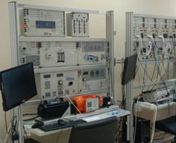

**Electric Power Generation Plant:** Cylindrical Rotor Generator set with accessories, Servo-drive/braking system (Turbine), Salient Pole Generator set with accessories, Servo-drive/braking system (Turbine), Protection Relays For Generators, Software SCADA Viewer for Power Lab. Universal power supply for DC and Three-Phase Current. Three Phase Smart Power Quality Meter with display and long-term memory. PC for each workstation.  
  
**Transmission Lines and Transformers with Protection:** Transmission line Models 150km/300km, Step-down transformer model, 3-ph Inductive load, 3-ph Capacitive load, 3-ph Variable Ohmic load. Power switch module. Overcurrent time relays, Directional overcurrent time relay, Transformer / Generator differential protection relay. Reverse power relay Adjustable 3-phase power supply, Three Phase Smart Power Quality Meter. PC for each workstation.  
  
**Electric Power Distribution and Smart Grid:** Three-phase double busbar system, Bus coupler, Protection for Busbars systems, Inductive and resistive loads, Three-phase asynchronous motor, squirrel-cage, Star-delta switch, Reactive Power controller, Switchable Capacitor Bank, Three Phase smart power Quality meter.  
  
**SCADA SYSTEM (Hardware and Software )**  
**Pumped storage power plant**  
**Wind power plants:** Double Feed Induction Generator  
  
**Photovoltaic power plant:** PV modules, Solar module simulation model, Solar module with solar altitude emulator, Load unit, Solar charge controller, Solar Accumulator, Off-grid inverter, Industrial photovoltaics inverter, AC & DC Lamp boards