New lab for urban and mobility transportation by Upgrade Erasmus project

**- 3 Drawing Halls.**Architectural studios are provided with curtains that allow students to adjust it to different levels according to their preferences.

**- 2 Computer Labs.**Computers are provided with licensed programs such as Revit and Sketchup for students to use in different computer application courses

* **1 Maker space room (3D printing, laser machine, etc.)**

This space is dedicated to advanced digital fabrication, equipped with laser cutters, 3D scanners, and 3D printers to support precision prototyping and creative design.

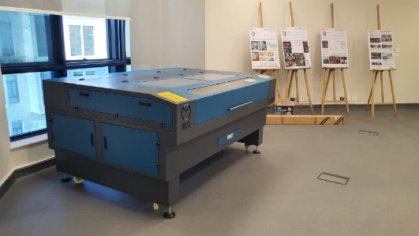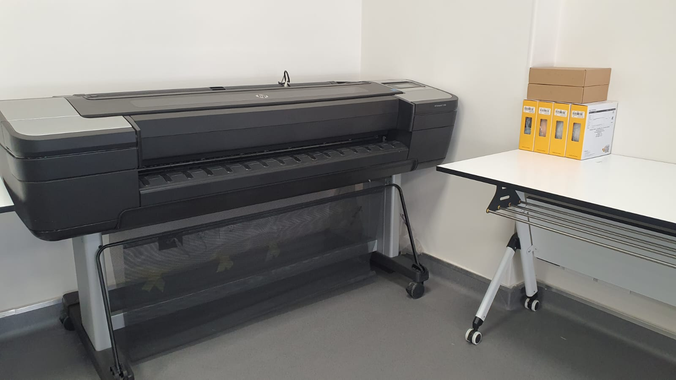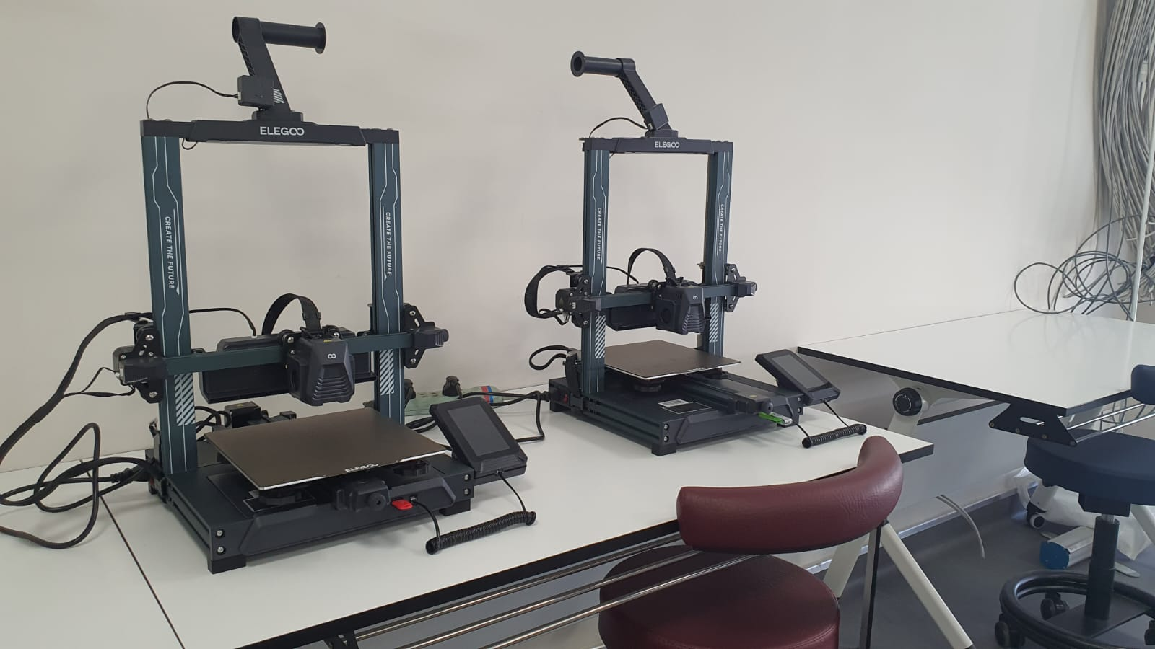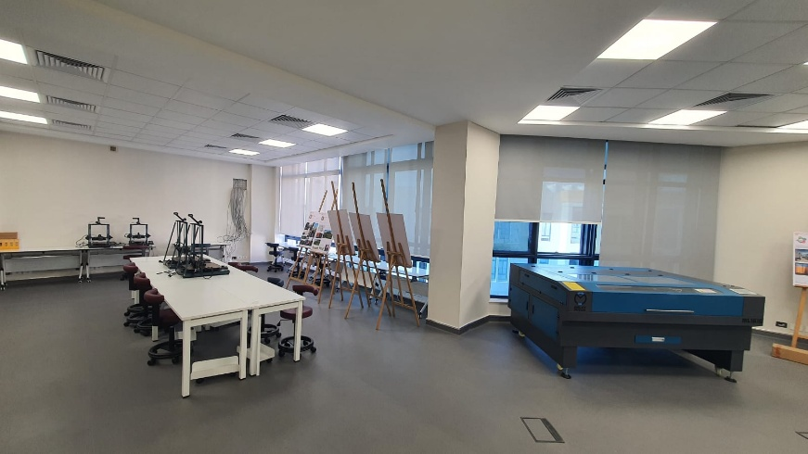

* **1 Digital lab (VR tools)**

The room is a cutting-edge digital lab equipped with advanced technologies, including high-performance computers and immersive VR goggles. It serves as a dynamic space for innovation, enabling users to explore virtual environments and conduct interactive simulations.

* **A room with chairs and a table

  Description automatically generated2 Digital Studios**

