Resources and Laboratories

- Mechatronics Lab | 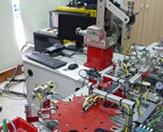
- Control & PLC Lab -Electromechanical Lab
- Thermodynamics & Heat Transfer Lab
- Fluids Lab
- Material Testing Lab
- CAD Lab
- Digital electronics
- Basic Electronics
- Embedded System Lab
- Mechanical Workshop
- PLC & Electromechanical Lab

