**SPE OnePetro Online Library**

Committed to enhancing our students’ skills, we have secured a subscription to SPE OnePetro, ensuring access to the latest advancements in oil and gas technology. OnePetro is a comprehensive online library dedicated to technical literature in the petroleum exploration and production sector. Established in 2007, it houses technical papers from over 25 current and historic industry journals, as well as proceedings from more than 50 conferences held globally. With over 1.2 million searchable documents, OnePetro serves as the definitive resource for upstream oil and gas information.

**Basic Petroleum Engineering Labs**

The Petroleum Engineering Department offers state-of-the-art facilities and equipment, including the Reservoir Laboratory (“Core Lab”), Drilling Fluids Laboratory, Cement Laboratory, and Software Laboratory—generously provided and operated by SLB. These resources enhance both education and research capabilities. Additionally, our program is guided by expert supervision to continuously update the curriculum, incorporating emerging fields such as Artificial Intelligence and Data Analysis, which are increasingly vital to the industry.

**Drilling Fluids and Cement Lab.**

* Location: Room A5.7
* Capacity: 20 Students

Main Equipment / Apparatus

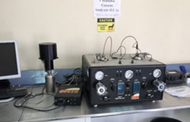

Mixers, Rheometers (Viscometers), March Funnels, Triple Beam Balance, Normal Mud Balance, Pressurized Mud Balance, Filter Press Set, HTHP Consistometer, Ultrasonic Cement Analyzer

**Core Analysis Lab.**

* Location: Room A5.5
* Capacity: 20 Students

Main Equipment / Apparatus

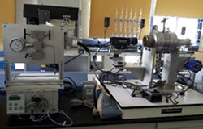

Diamond Tooled Drill Press Machine (Plugging Machine), Diamond Tooled Trim Saw TRM-100, Cool Soxhlet Cleaning System, Dean Stark Extraction System, Chemical Fume Hood, Gas Permeameter, Liquid Permeameter, Auto-Saturator, Resistivity Tower, Resistivity Meter with Ambient Core Holder, Capillary Pressure System, Falling Ball Viscometer, Relative Permeability Rig, Universal Humidity Oven, Pendant Drop Interfacial Tension, IFT-10-P, Sonics Ultrasonic Homogenizer

**Software Lab.**

* Location: Room A4.3
* Capacity: 10 Students

Main Equipment / Apparatus

We have several high-performance computers equipped with a donated SLB software package. This donation includes 15 licenses for key industry software such as Petrel, Techlog, PetroMod, and Eclipse—widely recognized as some of the most essential tools in the oil and gas sector.