# Engineering Enterprises for Civil & Steel Constructions S.A.E (EEC Group)

## October 27, 2021

# Construction of Light Rail Transit (LRT) Project

## December 22, 2021

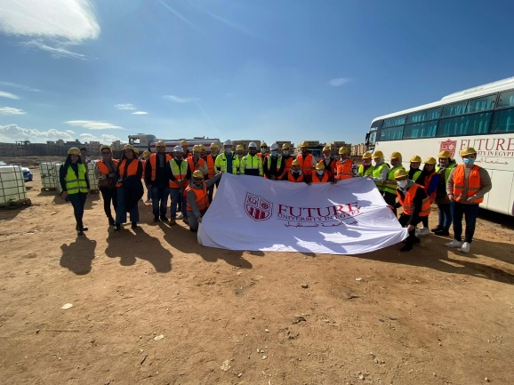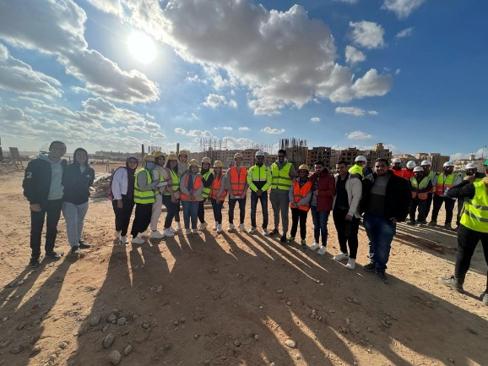

# Cairo Monorail Project (New Administrative Capital)

## December 29, 2021

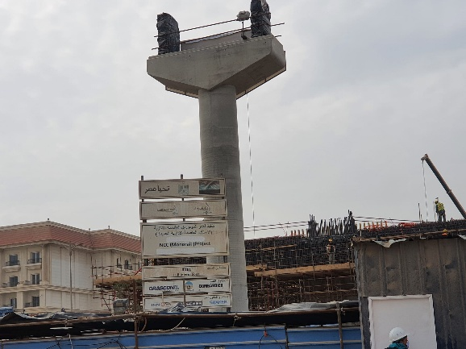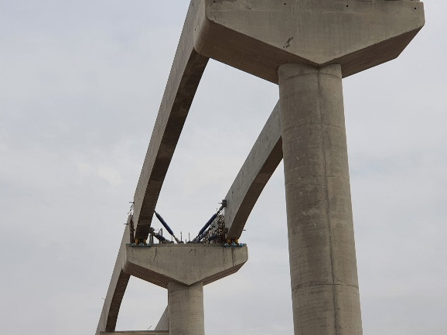

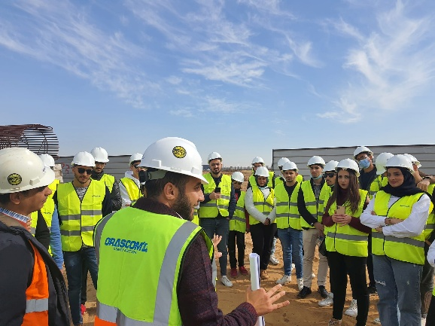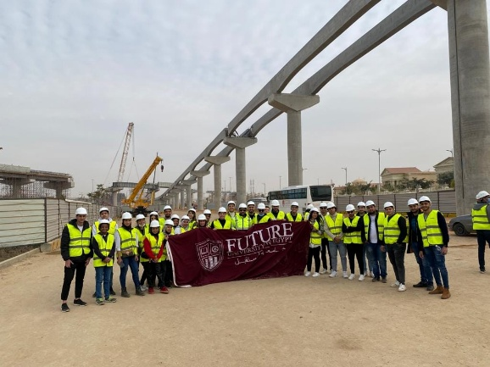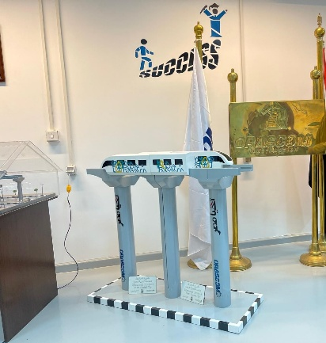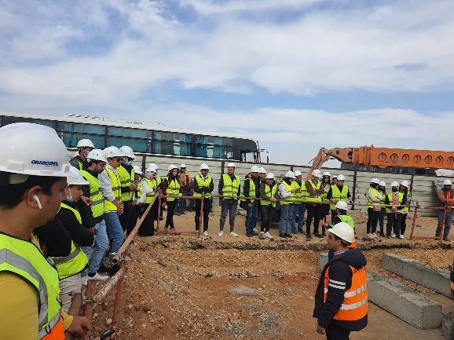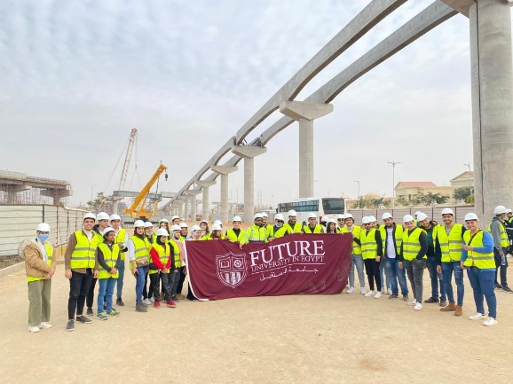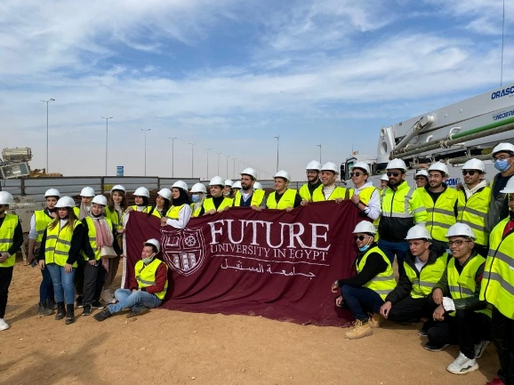

# Cairo Monorail Project (New Administrative Capital)

## March 23, 2022

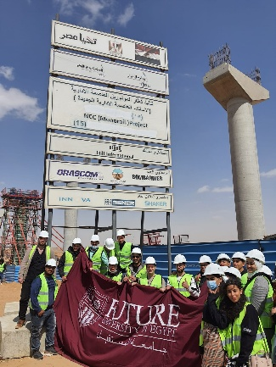 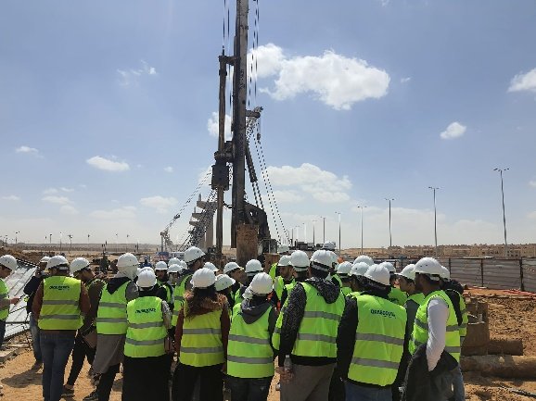 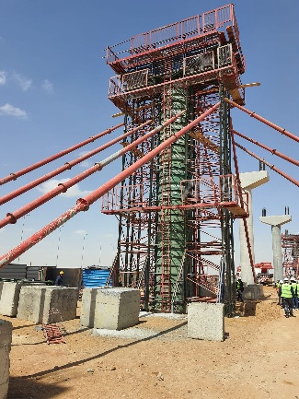 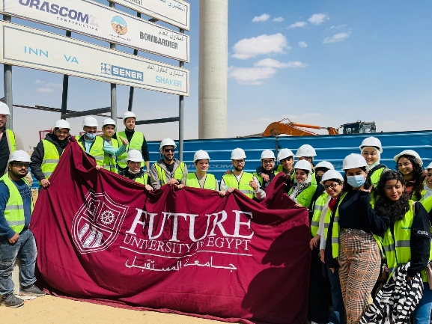 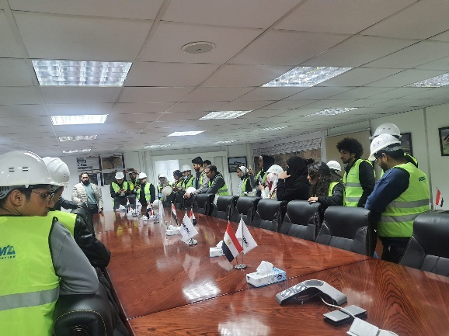 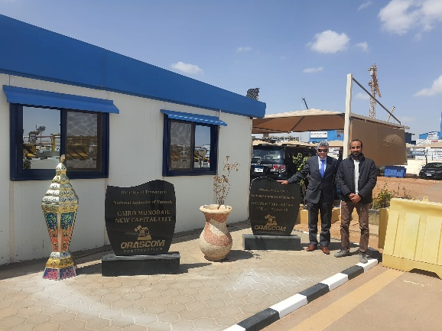 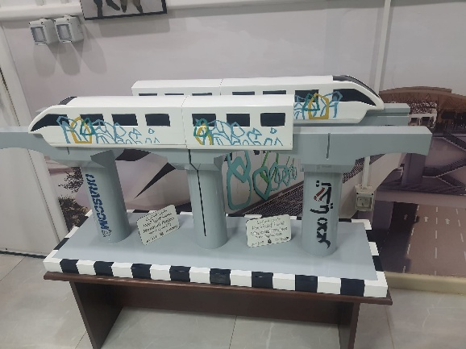

# Olympic City

## June 24, 2023

# Engineering Enterprises for Civil & Steel Constructions S.A.E (EEC Group)

## November 2, 2023

# The Hydraulics Research Institute National Water Research Center

## December 20, 2023

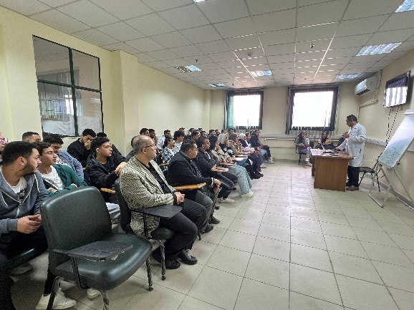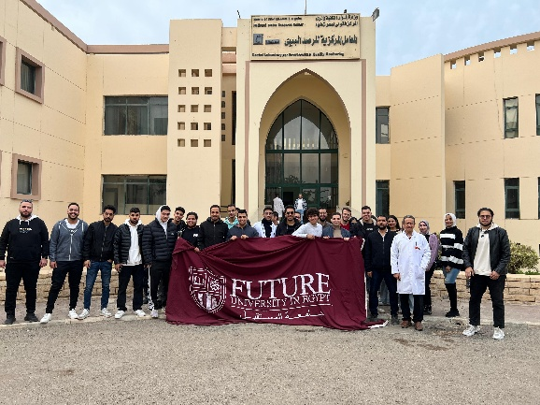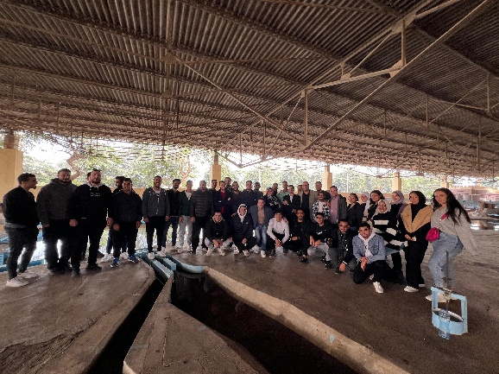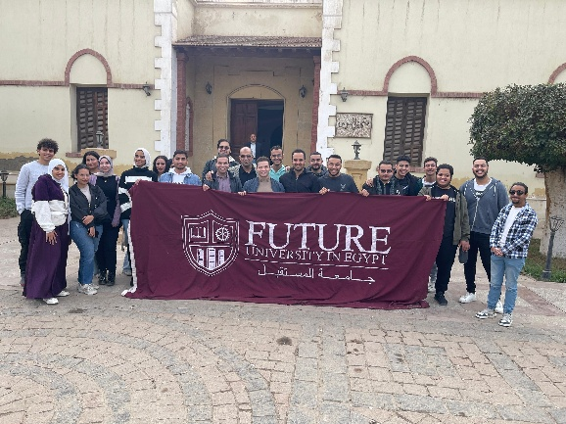

# مشروع انشاء كوبري خور مايو

## March 6, 2024

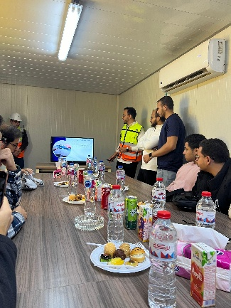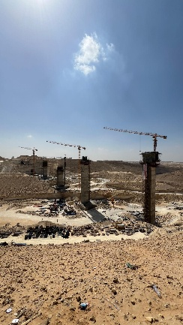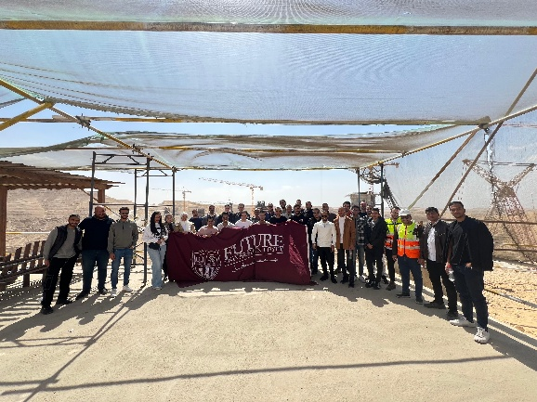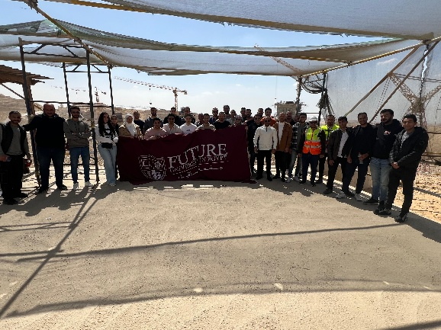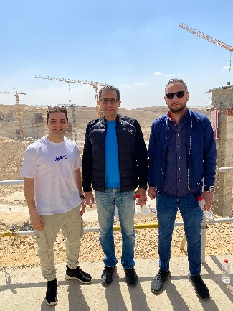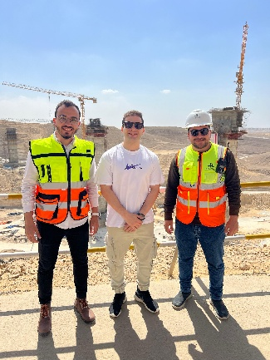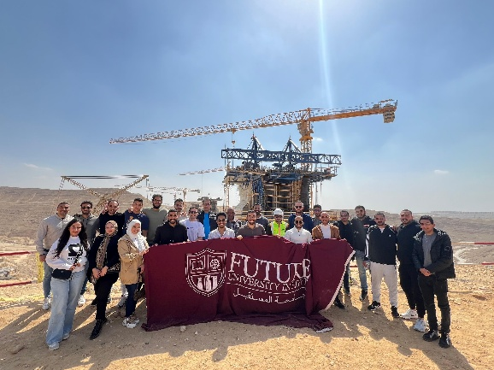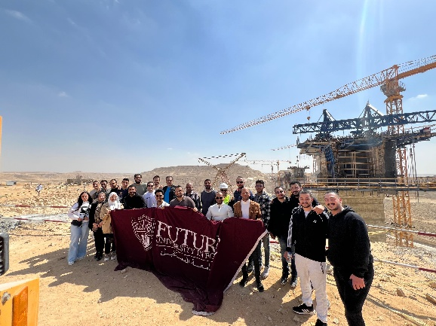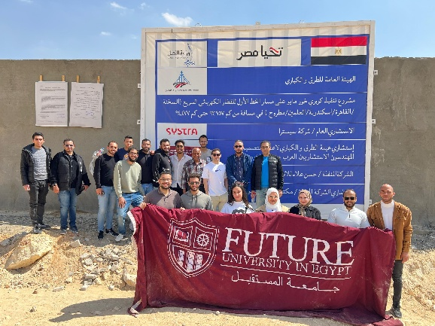

# محطة شركة البدري للمقولات

## December 17, 2024

